**VPC-2 TASK**

1. **Create one VPC,with 1 one public subnet and 1 private subnet.**

VPC ---> Your VPC --->click Create VPC

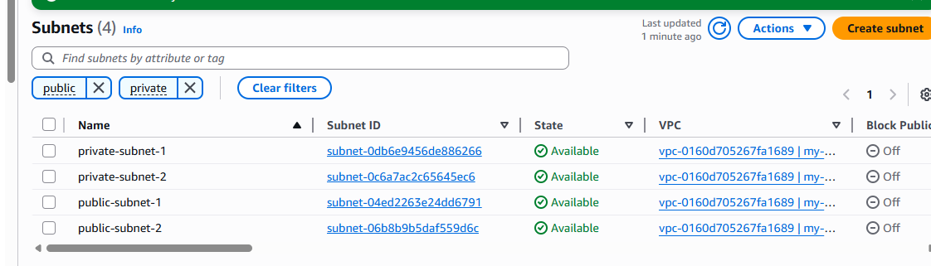

Add your VPC in VPC ID

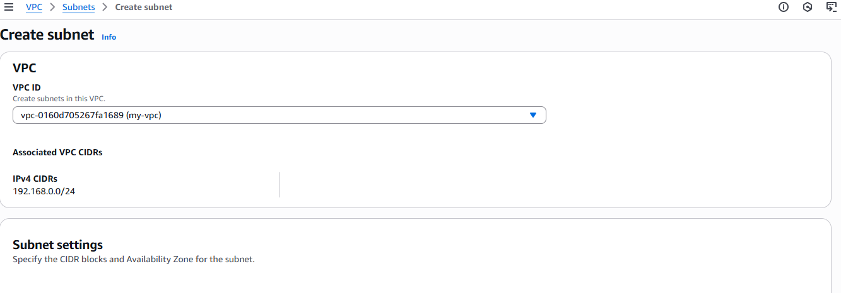

Enter reqired IPV4 subnet CIDR block

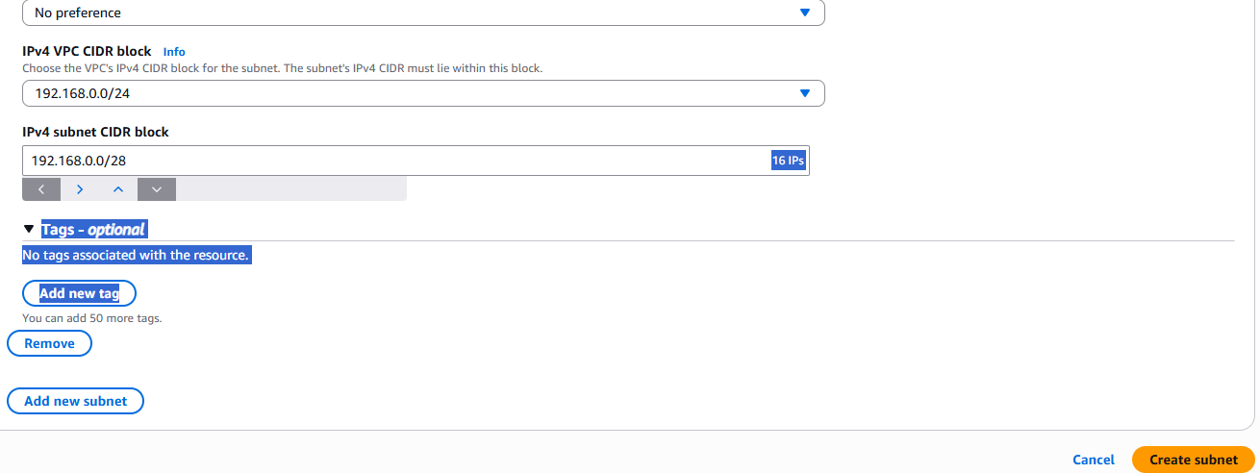

**STEP:2**

To create Public subnet

VPC ---> Subnets --->Create Subnets --->

**Add created VPC ---> Enter Subnet name ---> To pick availability zone ---> Enter required IPv4 CIDR block --->click Create Subnet**

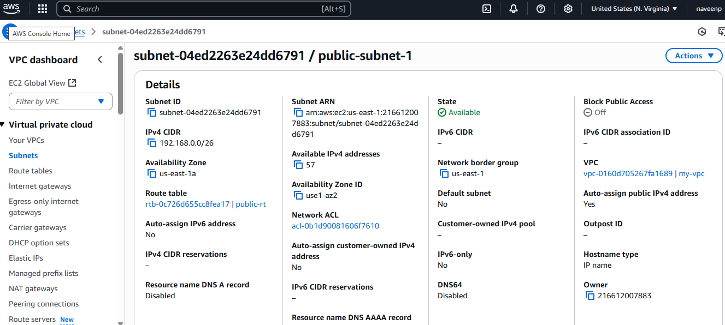

To create Private subnet

VPC ---> Subnets --->Create Subnets --->

**Add created VPC ---> Enter Subnet name ---> To pick availability zone ---> Enter required IPv4 CIDR block --->click Create Subnet**

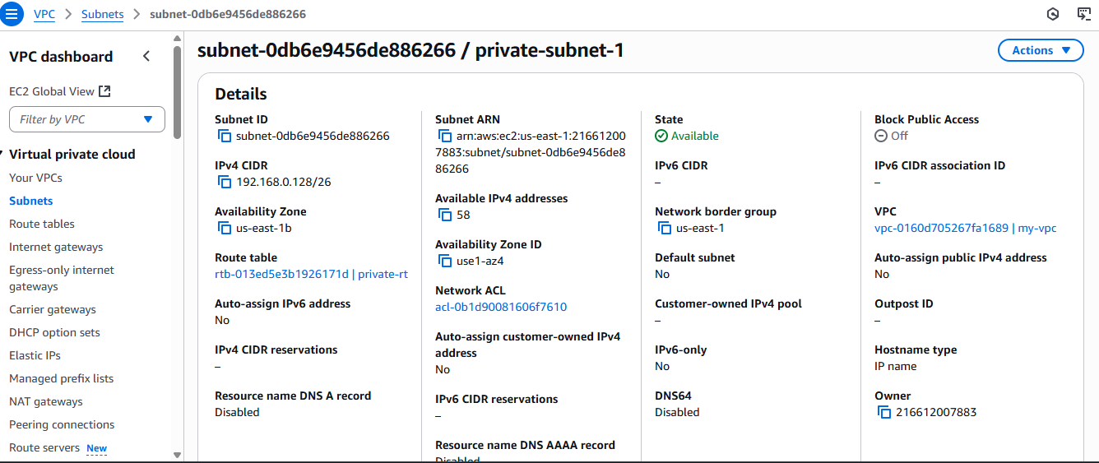

**STEP:3** To create Internet Gateway

VPC ---> Internet Gateways ---> Create internet gateway ---> Enter name

--->Click internet gateway

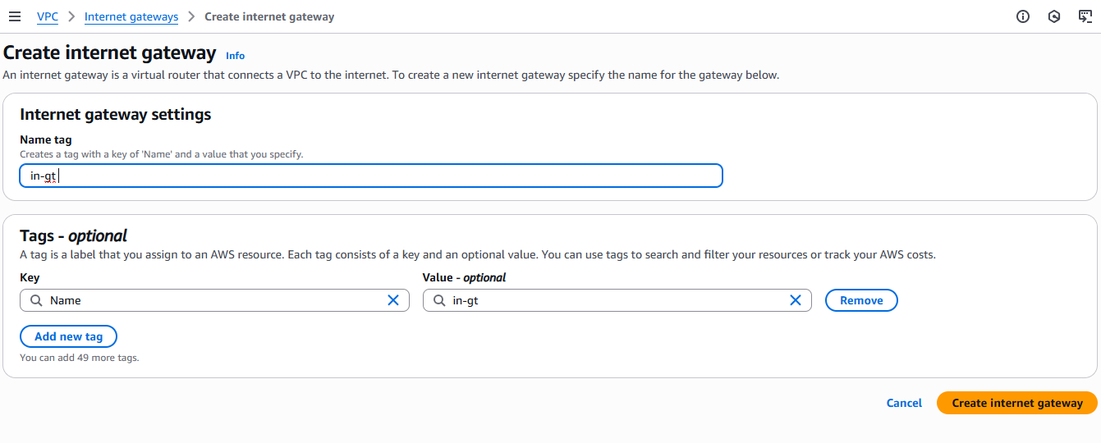

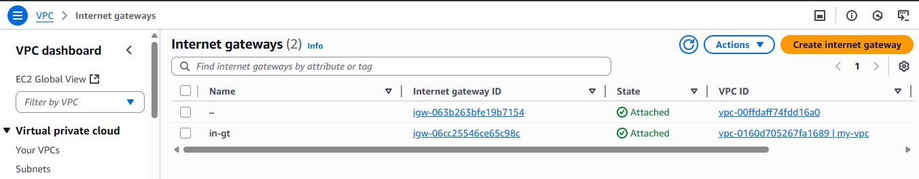

Attach Internet gateway to created VPC

**STEPS:**

Create Route Table

Public route Table

VPC ---> Route Table --->create route tables

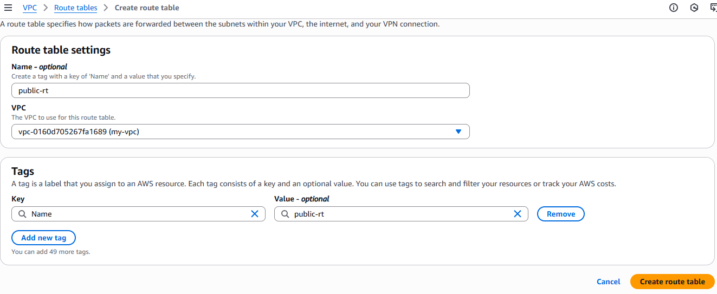

After creation

Route Table --->Select created route ---> Actions ---> Edit routes

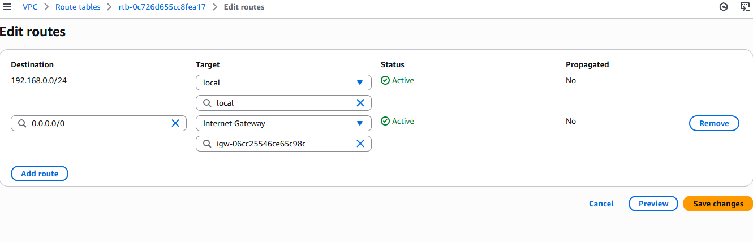

Route Table --->Select created route ---> Actions ---> Edit subnet association

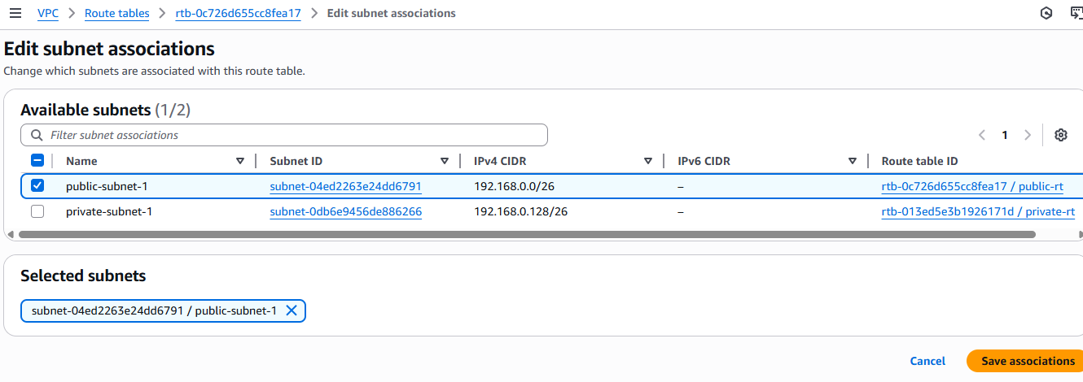

Create Private Route Table as like Public Route Table.

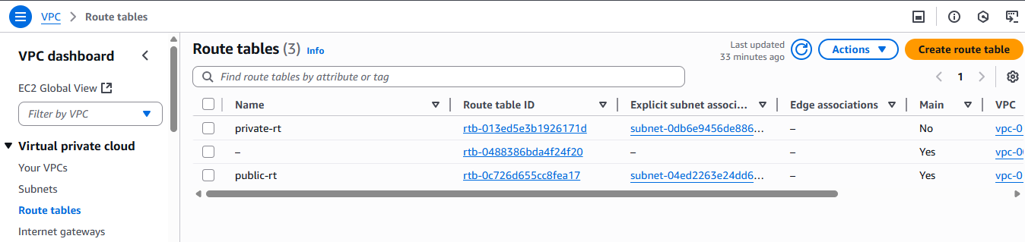

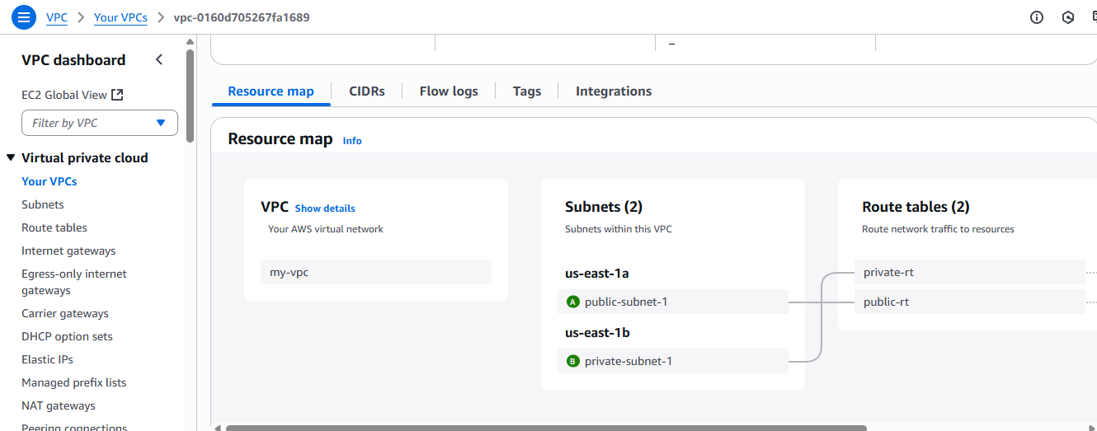

1. **Enable VPC peering for cross region.**

First to create two VPC on different regions A and B.

In region_A to create VPC peering

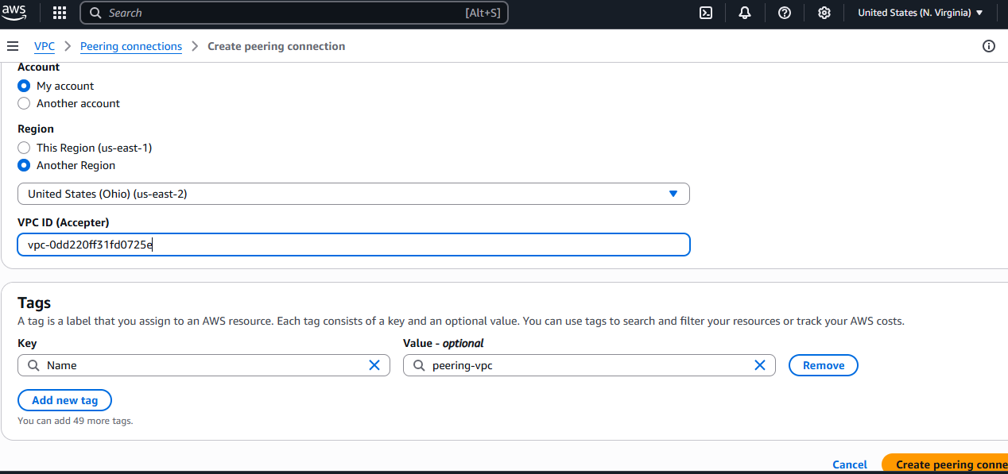

send a request to another region_B

Then the region_B accept the region_A request.

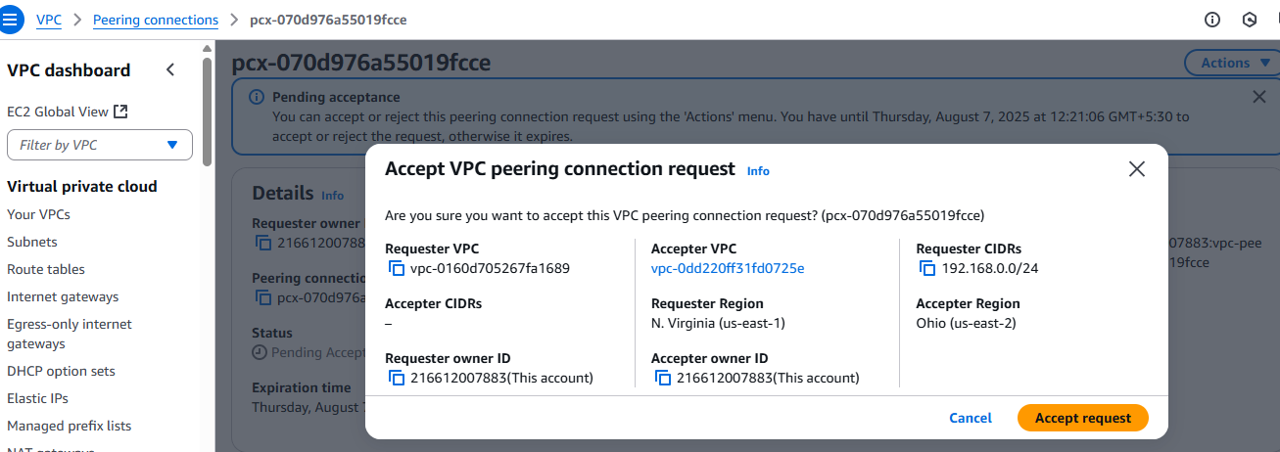

In both the regions go to Route table to edit route

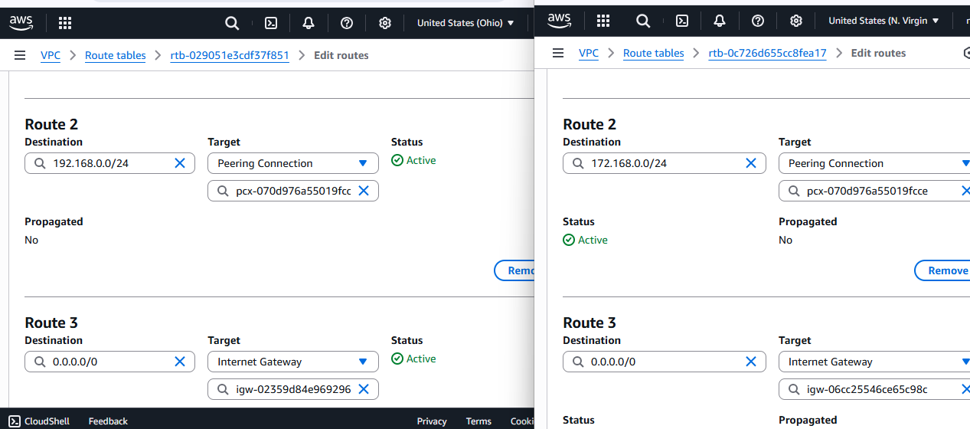

Both region instances.

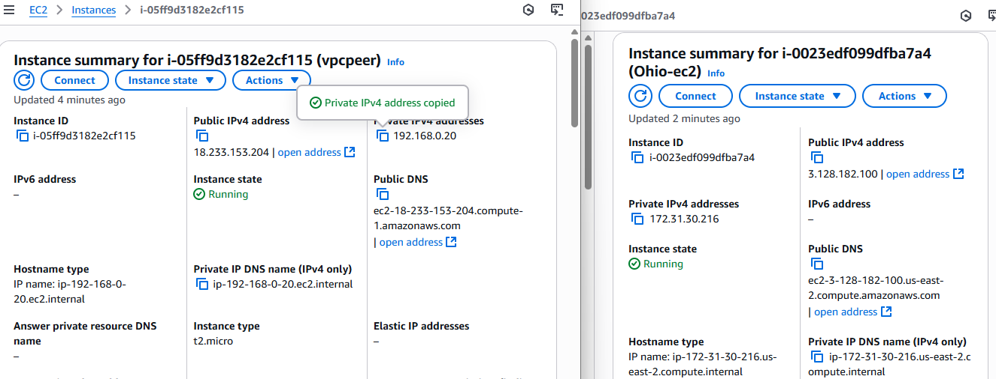

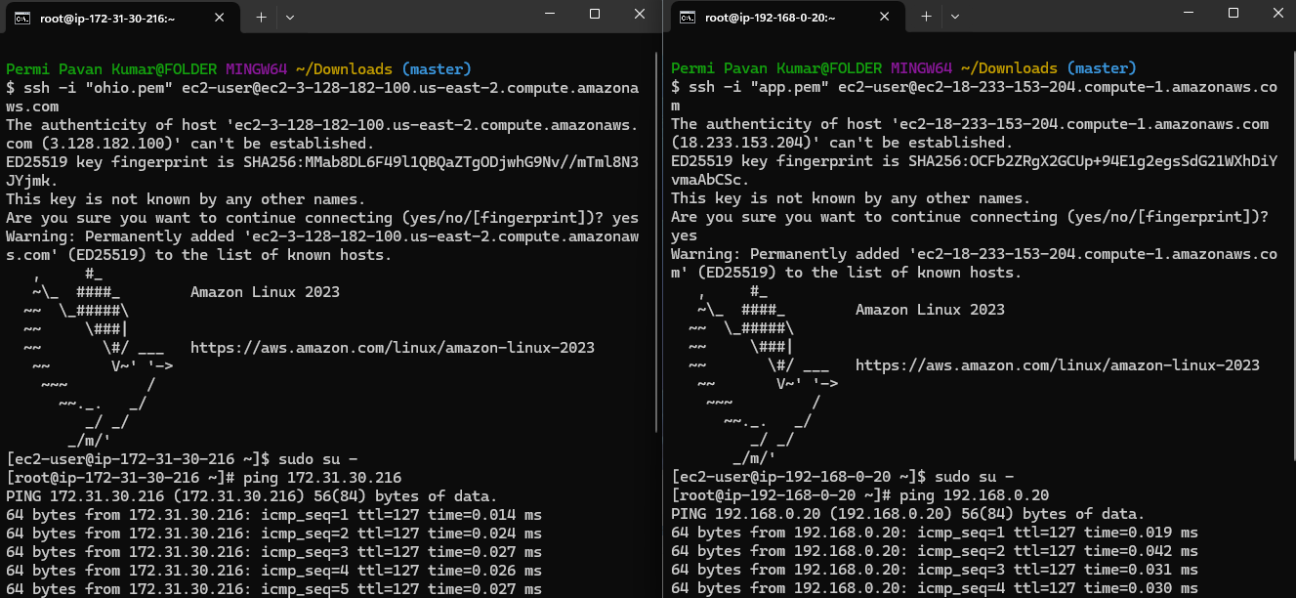

1. **Enable VPC peering for cross account. (You can collaborate with your friend and do this task).**

**To VPC Peering**

VPC ---> VPC peering ---> Create peering connection

Add your created VPC and VPC CIDR range

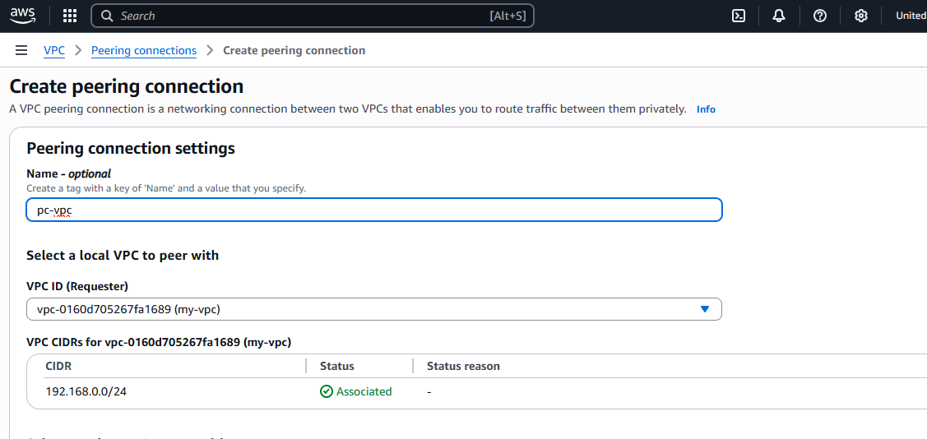

**Add** your friend account ID, Region and VPC ID.

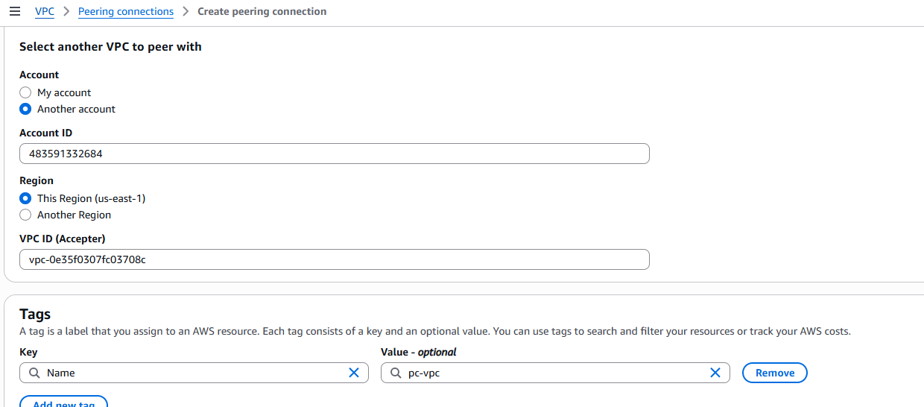

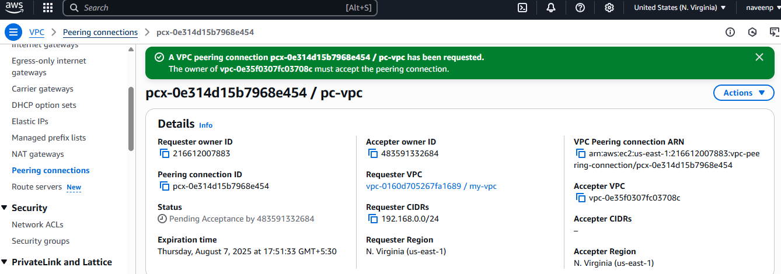

**Edit Routes in Route tables**

VPC ---> Route tables ---> Select created Route --->

Add your’s friend VPC IPv4 CIDR range in peering connection

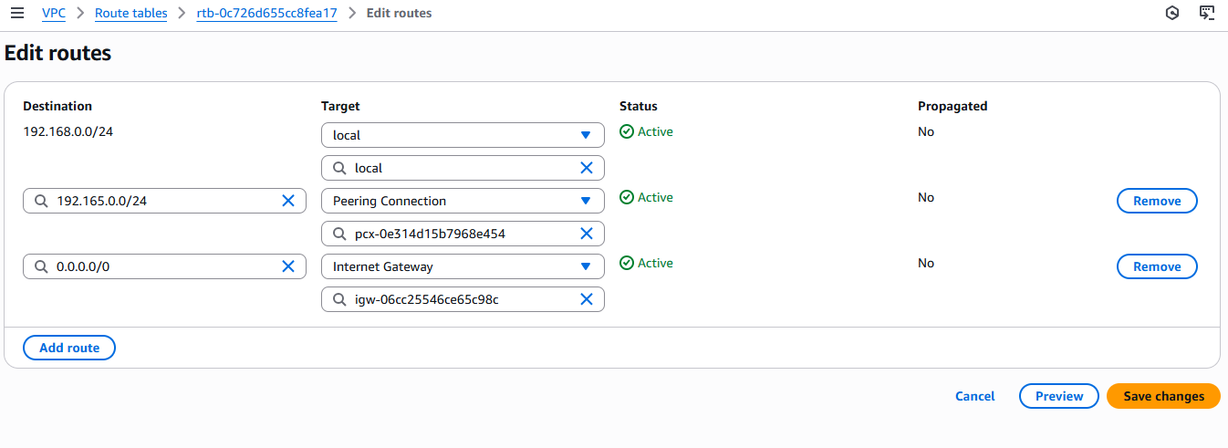

Connect your **ec2 instance with public Ip** and ping with **friend’s private Ip address of ec2 instance** to test the connection.

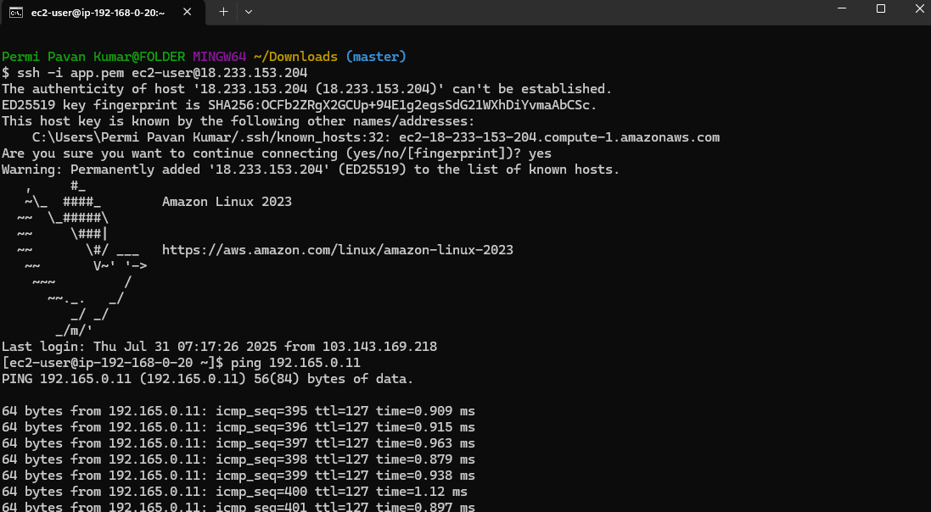

1. **Setup VPC Transist gateway.**

**STEP:1**

To create 4 VPCs

**VPC ---> Your VPCs --->Create VPC**

Ex:-

VPC-Public-192.168.0.0/24 and 1 Public subnet-192.168.0.0/24

VPC1-10.0.0.0/28 and 1 Private subnet-10.0.0.0/28

VPC1-10.0.0.0/28 and 1 Private subnet-10.0.0.0/28

VPC2-10.0.1.0/28 and 1 Private subnet-10.0.1.0/28

VPC3-10.0.2.0/28 and 1 Private subnet-10.0.2.0/28

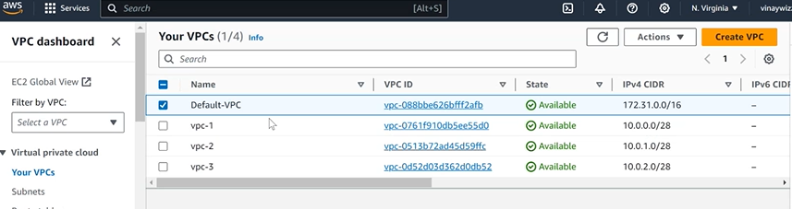

**STEP:2**

To create 4 subnets for 4 VPCs

**VPC ---> Subnets --->Create Subnets**

**STEP:3**

To create Transit gateway

**VPC ---> Transist gateway --->Create Transist gateway**

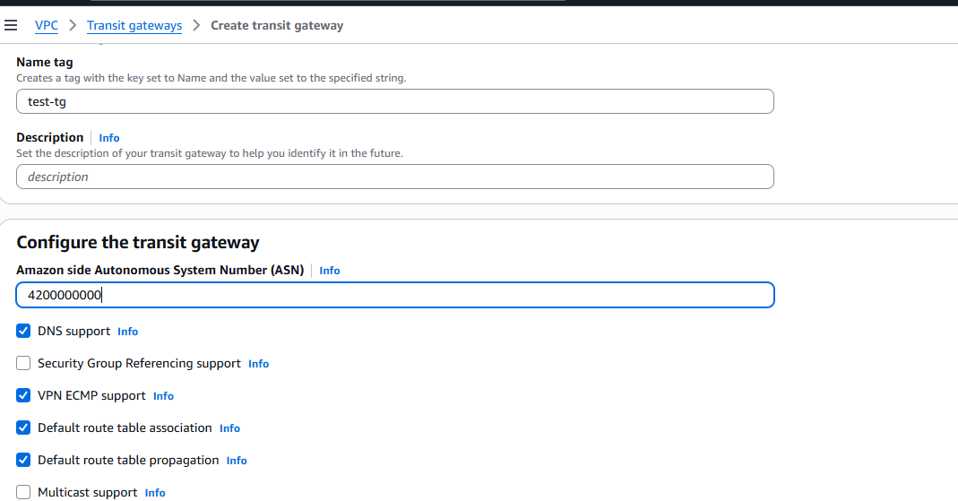

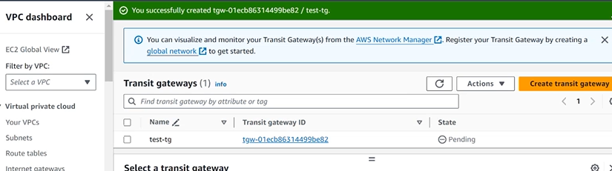

**STEP:4**

Attach VPC to Transit gateway attachments

**VPC ---> Transit gateway attachments ---> Create Transit gateway attachments**

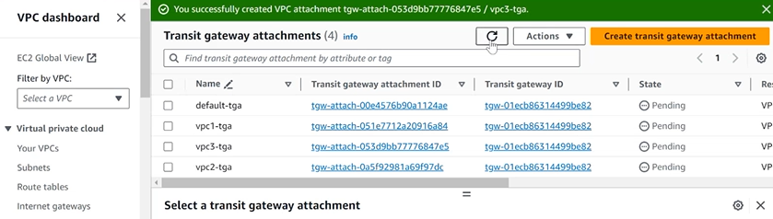

To check the attachmentsin**Transit gateway route table.**

**STEP:5**

To create 4 instances with 4 created VPCs.

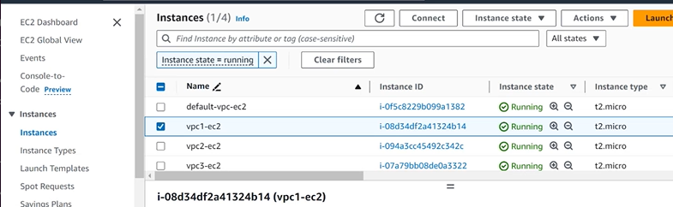

**STEP:6**

Go to edit route in Route table to attach Transit gateway in reqired Route.

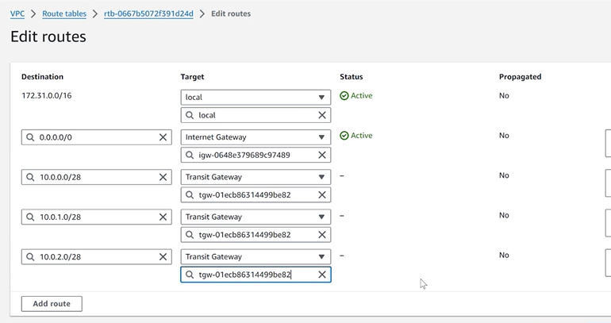

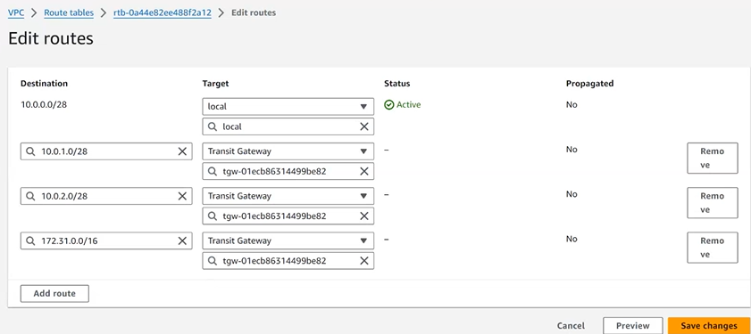

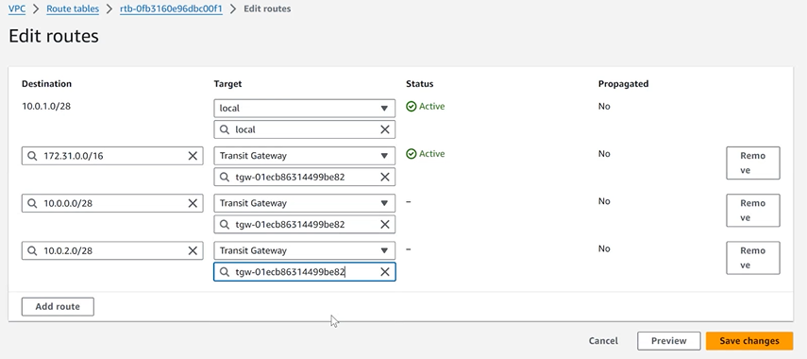

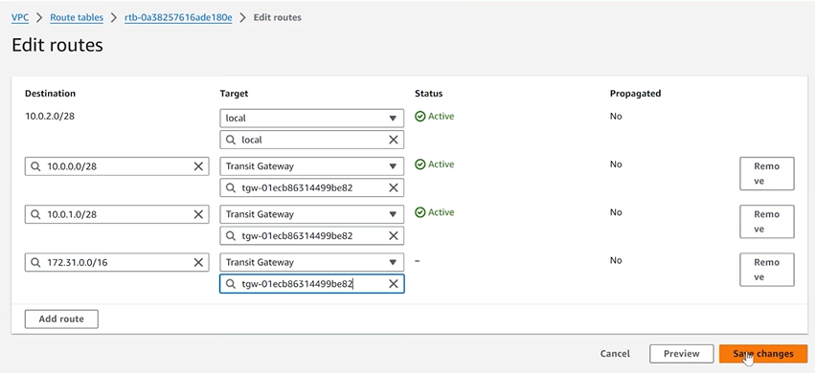

1. **Setup VPC End Point.**

VPC ---> Endpoints ---> Create endpoint

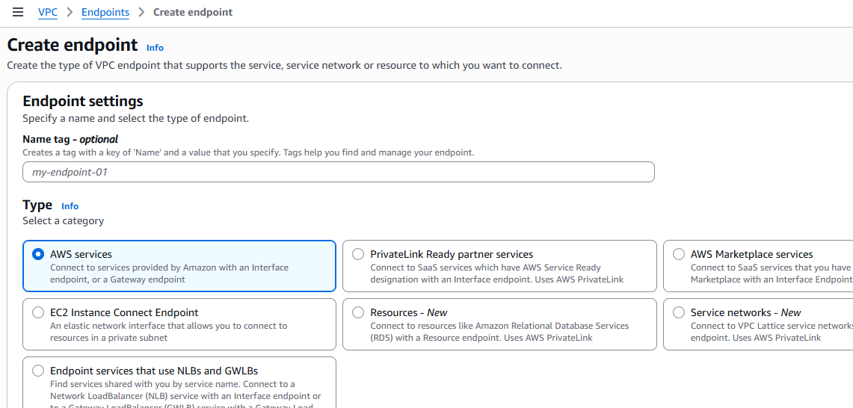

Select **Service Name = com.amazonaws.us-east-2.s3** in Services

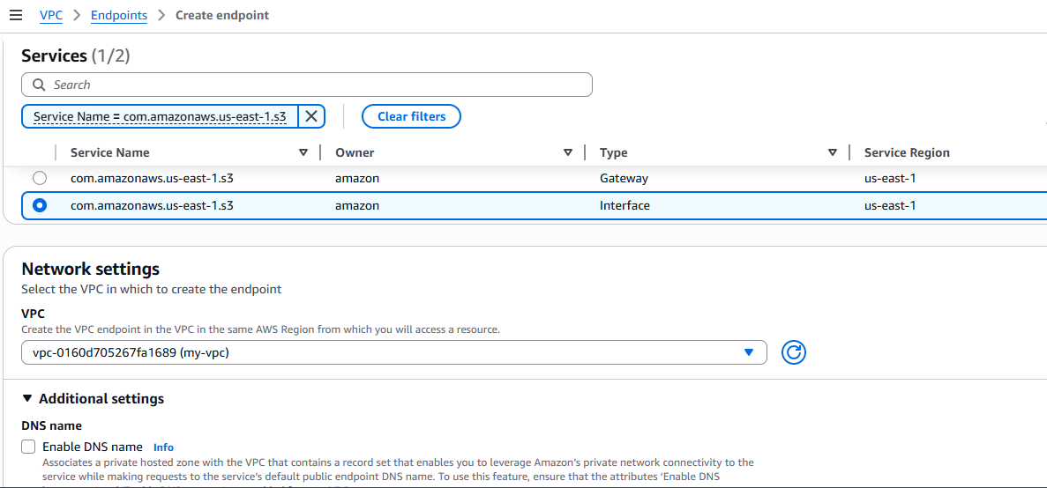

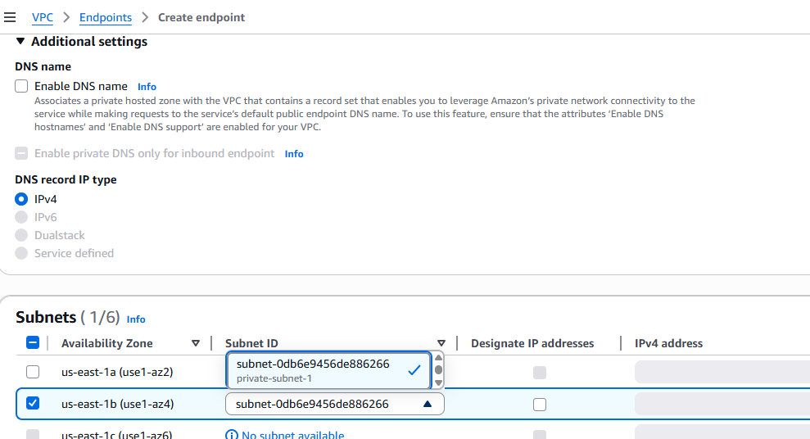

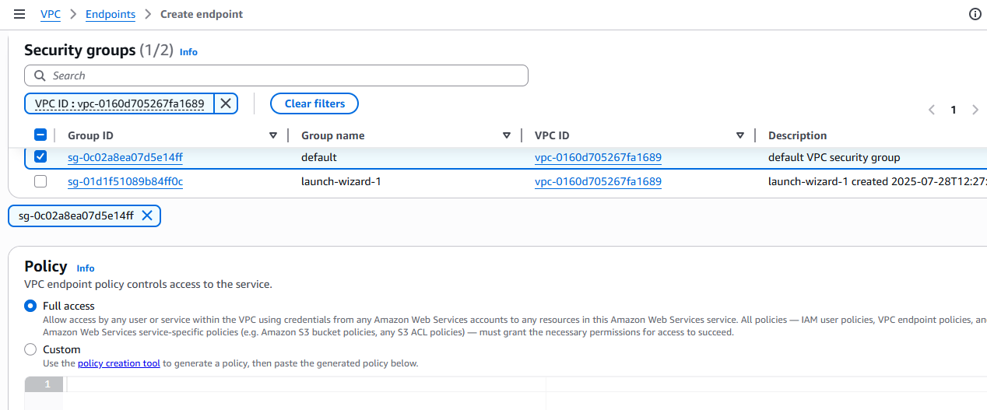

Click create endpoint

